Pizza Sales Analysis Using SQL

- Total Revenue :
select SUM(total_price) as "Total Revenue" from pizza_sales

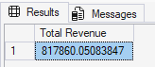

- Average Order Value :
SELECT SUM(total_price)/COUNT(DISTINCT order_id) as "Average Order Value" from pizza_sales

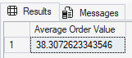

- Total Pizzas Sold :
select SUM(quantity) as "Total Pizzas Sold" from pizza_sales

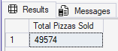

- Total Orders Placed :
select Count(DISTINCT order_id) as "Total Orders Placed" from pizza_sales

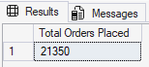

- Average Pizzas Per Order :
select Cast(sum(quantity)*1.0/(Count(Distinct order_id)*1.0)as Decimal(10,2))as "Average Pizzas Per Order"
from pizza_sales

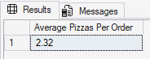

- Daily Sales Trends:
select DateName(DW, order_date) as [Order Day], Count(Distinct order_id) as "Total Orders"
from pizza_sales
Group By DateName(DW, order_date)

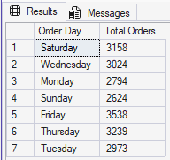

- Hourly Trend :
select DatePart(HOUR, order_time) as "Hour",
Count(Distinct order_id) as [Total Orders]
from pizza_sales
Group By DatePart(Hour, order_time)
Order By DatePart(Hour, order_time)

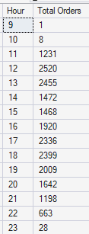

- Sales Percentage By Pizza Category :
select pizza_category,
Cast(
sum(total_price)*100.0/
(select sum(total_price) from pizza_sales)
as Decimal(10,2)
)
as [Sales Percentage]
from pizza_sales
Group By pizza_category

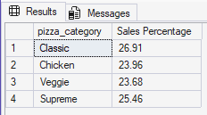

- Sales Percentage by Pizza Size :
select pizza_size,
Cast(sum(total_price) as Decimal(10,2)) as "Total Sales",
Cast(sum(total_price)*100.0/(select sum(total_price) from pizza_sales) as Decimal(10,2)) as [Sales Percentage]
from pizza_salesGroup By pizza_size
Order By [Sales Percentage] DESC

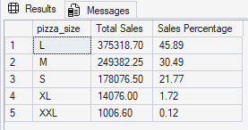

- Units Sold Per Pizza Category:
select pizza_category, sum(quantity) as [Units Sold]
from pizza_sales
group by pizza_category

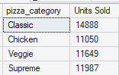

- Top 5 Pizzas Sold w.r.t Quantity :
select Top 5 pizza_name, sum(quantity) as [Units Sold]
from pizza_sales
group by pizza_name
order by [Units Sold] DESC

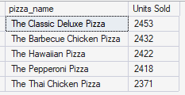

- Top 5 Underperforming Pizzas :
select Top 5 pizza_name, sum(quantity) as [Units Sold]
from pizza_sales
group by pizza_name
order by [Units Sold] ASC

